MULECO – Multilingual Upper-Level

Electronic Commerce Ontology

What the project hopes to achieve

This CEN/ISSS Electronic Commerce Workshop project will research the most efficient means of developing a multilingual upper-level ontology for describing and identifying the relationships between electronic commerce applications and the ontologies used to describe them. In particular it will investigate how information related to business processes can be integrated with existing techniques for classifying businesses, their products and services.
There are many existing and proposed "electronic commerce ontologies". The vast majority have been defined monolingually, or in at most three or four languages, often from the same language group. The problem is that different trading partners tend to use different ontologies, and tend to prefer ontologies developed in their native language or in a "neutral" language, which is often English. It is, therefore, difficult to identify points of overlap between ontologies, and it is also difficult for people to find relevant terms in ontologies using their native language.
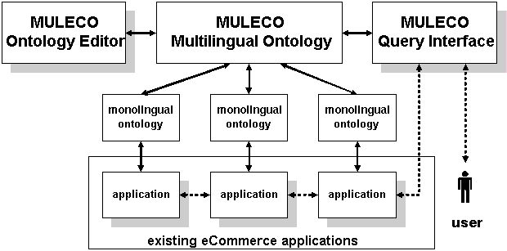
Figure 1: The relationship of MULECO to eCommerce Applications
The aim of MULECO is to develop a mechanism that will allow existing ontologies to identify their inter-relationships by identifying the relationships between themselves and a set of terms defined in a multilingual ontology that has been designed specifically to allow people to find terms using their native language. We realise that it is not possible, or desirable, to create and maintain a multilingual ontology that covers all terms used in all business applications in all European languages. What is needed is a way of classifying entries at the upper-most levels of existing ontologies in a form that takes account of the sort of terms used by people when they are trying to locate the term(s) they wish to use. To do this we need to extend existing business classification schemes to take account of things like business processes, variant names within different user communities, exclusion properties (e.g. no peanuts), etc. Such extensions need to be based on a well documented model that is based on properly researched linguistic characteristics, such as that provided by the Expert Advisory Group in Language Engineering Standards in The EAGLES Guidelines for Lexical Semantic Standards provided in Chapter 6 of EAGLES LE3-4244: Preliminary Recommendations on Lexical Semantic Encoding -- Final Report (http://www.ilc.pi.cnr.it/EAGLES96/EAGLESLE.PDF).
The MULECO project will develop an upper-level ontology, expressed as an extended network of industry descriptors, commercial terms and business roles, that will be recorded in a way that allows each entry to be addressed from other ontologies and applications by means of a Uniform Resource Identifier or an XML Path/Query.

The upper-level ontology will take as its start point existing standardized industry and process classification schemes, such as the International Standard for Industrial Classification (ISIC) used as the basis for the NACE classification of European business. The project will take note of the work being done by the IST CLAMOUR project to formally define such classification schemes. In particular it will extend currently used techniques for data classification, based on hierarchical classification of terms into broader and narrower meanings, by allowing for more complex relationships, in particular those relating to the relationships of wholes and parts which are vital to the mapping of the relationships between business processes. By defining a set of business relevant relationships between terms the project will allow classification hierarchies to become a controlled network of related words that forms an ontology rather than a classification scheme.

The ontology will be expressed in a language that provides the following functionality not currently found in electronic commerce ontologies based on languages such as RDF, OIL, KIF, etc, which the members of the CEN/ISSS Electronic Commerce Workshop feel are required to model different kinds of relationships between multilingual electronic commerce ontologies:

- The ability to uniquely identify the domain (e.g. industry sector) in which each term is employed
- The ability to formally record the meaning of the term within a particular domain
- The ability to identify other domains in which the same meaning applies
- The ability to record alternative terms that have the same meaning within the original domain
- The ability to identify alternative terms used for the same meaning in other domains
- The ability to identify an exactly equivalent term used in a different language
- The ability to identify a nearly equivalent term used in a different language
- The ability to identify terms that form a part of an object defined by a term
- The ability to identify wholes that a term forms a part of
- The ability to identify an opposite term or property (e.g. water-resistant/water-soluble)
- The ability to record relationships between terms or properties
- The ability to identify opposite relationships (e.g. isMother/isChild)
- The ability to declare properties that record measurements
- The ability to declare properties that record times
- The ability to associate terms with specific points in process chains

Monolingual ontologies that are linked to the multilingual ontology will be able to make use of equivalences expressed in the multilingual ontology to extend their search potential. This will allow companies that have developed electronic commerce applications for a single country/language to extend their applications to other European countries and beyond without having to change their underlying data dictionaries. With the forthcoming extension of the European Single Market into Eastern Europe and the Mediterranean there will be an increasing need for tools that allow the creation and maintenance of complex multilingual business ontologies of the type to be developed by this project. The project will evaluate the problems associated with developing multilingual ontologies, methodologies and techniques for overcoming them and the advantages to be gained from their use.

This project will incorporate and build on the concepts currently being developed to introduce monolingual ontologies into the Semantic Web. It will introduce such concepts into electronic commerce applications that are aimed at improving the flow of information between businesses within different language communities. At present most of the development work on the Semantic Web is postulated on the basis of using English language terms to identify the relationship between web resources and ontologies. Existing tools for applying the World Wide Web Consortium (W3C)’s Resource Description Framework (RDF) to the identification of related resources are generally postulated on the manual indexation of resources. Business applications require that this work be automated so that resource relationships can be identified automatically in a timely manner as part of business processes, without any human intervention. To be able to do this in a multilingual environment requires the use of a new generation of methodologies and tools. The project will seek to develop methodologies and tools for the creation and maintenance of multilingual ontologies, and for the querying of such ontologies.

The project hopes to:
- Develop a methodology for expressing a general-purpose ontology for describing the full gamut of electronic commerce applications
- Develop an open source tool to support the development and maintenance of the upper-level ontology
- Populate an ontology with Internet-addressable terms for describing electronic commerce applications and services, and the relationships between them
- Identify a set of existing electronic commerce ontologies and associate them with relevant terms in the upper-level ontology.
- Input draft specifications into the European and international standardization process.

The results of the project will be reviewed by members of the CEN/ISSS Electronic Commerce Workshop and other relevant standardization organizations.

Existing Techniques
The following techniques have been studied as possible bases for MULECO:

The EAGLES Guidelines
- Techniques for the Definition of Ontologies
  - IEEE Standard Upper-level Ontology (SUO)
  - DAML+OIL
- XML Representation of ISO 13250 Topic Maps
- Unified Modeling Language (UML)
- The Common Warehouse Metamodel (CWM) Business Nomenclature Package
- ISO 11179: Specification and Standardization of Data Elements
- The International Standard for Industrial Classification (ISIC)

The EAGLES Guidelines
The EAGLES project was concerned with Natural Language Processing (NLP). As such it had a very wide theme, and needed to cater for the large number of circumstances in which text is used. Many of its features were concerned with word disambiguation in different contexts that are not directly applicable to the more limited applications for which business semantics are required. This section only discusses those features of the EAGLES Guidelines that are directly relevant for the description of business semantics.

The EAGLES Guidelines for Lexical Semantic Standards provided in Chapter 6 of EAGLES LE3-4244: Preliminary Recommendations on Lexical Semantic Encoding -- Final Report (http://www.ilc.pi.cnr.it/EAGLES96/EAGLESLE.PDF) points out that:

“Hierarchical networks [describing hyperonym/hyponym (broader/narrower term) relationships] are very powerful structures because classifications at the top can be inherited to large numbers of word meanings that are directly or indirectly related to these top levels.”
and
“to achieve consistency in encoding hyponymy relations, the best approach is to build the hierarchy top down starting from a limited set of tops or unique beginners … Having an overview of the classes, even at a very high level, makes it possible to more systematically check the possible classes. Furthermore, a systematized top level makes it easier to compare and merge different ontologies.”

Business semantics will need someone to develop a top level hierarchy suitable for business uses if they are to be able to interoperate.

As is pointed out in the EAGLES Guidelines, many thesauri cluster words that are related in an unstructured way. For example, the standardized medical thesaurus MESH contains the following entries related to transportation:

Transportation
... Aviation
... ... Aircraft
... ... ... Air Ambulances
... ... Space Flight
... ... ... Extravehicular Activity
... ... ... Spacecraft

The terms Space Flight and Extravehicular Activity do not represent subclasses of transportation vehicles but are, rather, types of activities related to certain vehicles. Because of this, MESH can only be used to globally extract words that are related; it cannot be used to make inferences such as: all the things that can be used to transport people, goods, etc.
Ontologies of business semantics need to be structured in such a way that they can be used for making inferences.

Words can have different meanings in different contexts. A term that has more than one meaning is said to exhibit polysemy. Words that share the same meaning within a particular context are synonyms. Synonyms should be able to replace each other in stated contexts. If their replacement is not always possible they are referred to as near-synonyms. Near-synonyms have meanings that partially overlap each other. Terms that share the same parent hyperonym but do not overlap in meaning are known as co-homonyms. It is important that ontologies of business semantics be able to make these distinctions within the relationships they record.

Word-sense disambiguation is an important subtask for Information Retrieval, Information Extraction or Machine Translation. One of the key factors in disambiguation is the identification of the domain with which the relevant text is concerned. If you have identified the domains in which each meaning of a term applies you can disambiguate meanings by utilizing information relating to the domains of discourse within a resource.

While hyperonym/homonym relationships work for nouns they are not so useful for other parts of speech, which are generally harder to disambiguate. For most business related classification schemes, however, verbs and other parts of speech are of relatively low importance in identifying meaning. (Verbs identify relationships or actions: they can be useful to identify the role played by particular agents on particular objects. Roles can be classified to create thematic roles. Adjectives are used to describe properties of nouns, e.g. brown gloves. Adverbs, prepositions, conjunctions, etc, are not widely used in electronic business messages. Of key importance to business, however, are terms used for the quantification of measurements and for defining time.)

Many lexicons permit multiple hyperonyms (broader terms) to be associated with a homonym (narrower term). Three types of hyperonym have been identified within the EAGLES project: exclusive, conjunctive and non-exclusive. For exclusive hyperonyms one of a choice of meanings must be determined by context. Conjunctive hyperonyms allow more than one meaning to be associated with a given context. If either multiple meanings or a single meaning can apply in a given context the hyperonym is deemed to be non-exclusive.

The EAGLES-based EuroWordNet distinguishes between Entities, Concepts, Events and States. Each of these is further divided, with up to 5 levels of subdivision. A typical EuroWordNet entry has the form:

[ -ORTHOGRAPHY : horse
-WORD-SENSE-ID : horse_1
-BASE-TYPE-INFO : [ BASE-TYPE: ANIMAL
LX-RELATION: LX-HYPONYM]
[ BASE-TYPE: OBJECT
LX-RELATION: LX-HYPONYM]
SYNONYMS : Equus_caballus_1
HYPERONYMS : [HYP-TYPE: conjunctive
HYP-ID: animal_1]
[HYP-TYPE: conjunctive
HYP-ID: equid_1]
[HYP-TYPE: non-exclusive
HYP-ID: pet_1]
[HYP-TYPE: non-exclusive
HYP-ID: draught_animal_1]
HYPONYMS : [HYP-TYPE: disjunctive
HYP-ID: mare_1]
[HYP-TYPE: disjunctive
HYP-ID: stallion_1]]

Meronymy is defined as a lexical part-whole relationship between elements. A good example is provided by human body parts. "Finger" is a meronym of "hand" which is a meronym of "arm" which is a meronym of "body". The "inverse relation" is called holonymy. “Body" is the holonym of "arm" which is the holonym of "hand" which is the holonym of "finger". The co-meronymy relationship is one between lexical items defining sister parts (arm, leg, head are co-meronyms of body). Meronymy is different from taxonomy because it does not classify elements by class. That is to say, the hierarchical structuring of meronymy does not originate in a hierarchy of classes (toes, fingers, heads, legs, etc, are not hierarchically related).

Not all meronyms are related to a single holonym. For example, "nail" is more general than its holonym "toes" as it can also be part of a finger as well. Cruse introduced the notions of super-meronym ("nail" is a super-meronym of "toes") and hypo-holonym ("toes" is a hypo-holonym of "nail") to allow for this.

The EAGLES paper recommends that "any lexical semantic standard should record a simple binary relation of antonymy where possible between [opposite] word senses". For example, "north" is the antonym of "south", and vice versa.

All of the above techniques can usefully be applied to multilingual business ontologies.

The on-going work, within the ISLE project for the development of International Standards for Language Engineering (http://www.ilc.pi.cnr.it/EAGLES96/isle/), on a Multilingual ISLE Lexical Entry (MILE) will extend the EAGLES Guidelines to cover the relationships between entries in different languages.

Techniques for the Definition of Ontologies
An ontology is a particular system of categories that provides a certain vision of the world. In the simplest case, an ontology describes a hierarchy of concepts related by subsumption relationships (e.g. lower-level terms meet the criteria set for higher-level terms). An ontology is the general framework within which catalogues, taxonomies, terminologies, etc, may be organized.

The key ingredients that make up an ontology are a vocabulary of terms and a precise specification of what those terms mean. But ontologies also analyse the fundamental categories of objects, their current state, and whether they form a part or the whole of something else, as well as the relations between parts and the whole and their laws of dependence.

Recently ontologists have started to explore the potential of process- and task-based ontologies. Rather than trying to describe all the characteristics of a particular universe or business domain, these more limited, time-aware, ontologies seek to provide information that is relevant for the management of a particular process or the completion of a specified task. One advantage of taking this approach is that it is much easier to develop intelligent agents that can make inferences based on such specialized domain knowledge than it is to create general-purpose inference engines of the type typically employed in AI systems. At this stage the question of how to identify the relationship between ontologies developed for specific processes and tasks has not been explored. Because it includes facilities for identifying the processes used by a particular business domain, however, MULECO should make it easier for intelligent agents, as well as human users, to identify ontologies that are relevant to their particular processes and tasks.

A formal ontology is the result of combining the intuitive, informal method of classical ontology analysis with the formal, mathematical method of modern symbolic logic. Over the years a wide range of formal ontologies have been proposed. To make it possible for ontologies to exchange data a number of "knowledge representation languages" have been developed, including KIF, Ontolingua, SNePS, HOL and Conceptual Graphs. Of these the most influential seems to have been the Knowledge Interchange Format (KIF). The basis for the semantics of KIF is a conceptualization of the world in terms of objects and relations among those objects. There are nine types of terms in KIF -- individual variables, constants, character references, character strings, character blocks, functional terms, list terms, quotations, and logical terms.

IEEE Standard Upper-level Ontology (SUO)

KIF, which is in the process of being published as a US standard by ANSI (see http://logic.stanford.edu/kif/dpans.html), has been chosen by IEEE as the basis for a Standard Upper-level Ontology (SUO). This upper ontology is limited to concepts that are meta, generic, abstract and philosophical, and therefore are general enough to address (at a high level) a broad range of domain areas. As well as very high level constructs such Independent Entity and Relative Entity SUO will cover such things as Agents, Persons and Organizations, using KIF definitions of the form:

(subclass-of Agent Object)
(subclass-of Person Agent)
(subclass-of Organization Agent)
(subclass-of Publisher Organization)
(subclass-of University Organization)
(disjoint Person Organization)
(subclass-of LegalObligation InstitutionalObligation)

and constructs for basic business functions, such as:

(subclass-of Quantity SpatialForm)
(subclass-of Weight Quantity)
(subclass-of Arrangement Schema)
(subclass-of Number Arrangement)
(subclass-of Set Arrangement)

SUO will also define instances of particular relationships, using formulations such as:

(instance-of hasAnnotation BinaryRelation)
(nth-domain hasAnnotation 1 Object)
(nth-domain hasAnnotation 2 TextObject)

and

(instance-of subProcess BinaryRelation)
(nth-domain subProcess 1 Process)
(nth-domain subProcess 2 Process)

Definitions can be assigned to SUO concepts using documentation statement of the form:

(documentation Agent "An active animate entity that voluntarily initiates an action.")

(documentation Arrangement "Mathematical structures that do not have spatial dimensions: numbers, sets, lists, algebras, grammars, and the data structure of computer science. Arrangement includes the subclasses whose names are derived from _taxis_, the Greek word for "arrangement", including taxonomies and syntax. All the syntactic forms in natural languages, programming languages, and versions of symbolic logic are included under Arrangement.")

As was the case with the all-encompassing lexical approach proposed by EAGLES, the proposed Standard Upper-level Ontology is designed to cover all knowledge, and therefore starts with concepts that are at much too high a level for the integration of business processes. It would be more correct to call it the Standard Top-level Ontology as it is designed to encompass all ontologies, rather than provide an upper level for a set of ontologies that cover specific areas, of the type proposed for the Multilingual Upper-Level Electronic Commerce Language.

Note: MULECO is not designed to integrate all existing ontologies, or to provide a meta-schema for describing ontologies. It is strictly limited to providing a means of identifying the relationships between existing ontologies by providing them with a set of addressable shared terms that they can link their top-levels to.

DAML+OIL

The Ontology Inference Language (OIL) that has been adopted as part of the DARPA Agent Markup Language (DAML) is an application of the W3C Resource Description Framework (RDF). DAML+OIL (http://www.daml.org/2001/03/reference.html) divides the world up into objects, which are elements of DAML classes, and datatype values, i.e., values that come from XML Schema datatypes, like the integer 4.
In DAML+OIL an ontology is recorded using a set of definitions that define classes, subclasses, properties that connect classes and individual instances. Classes have names, descriptive documentation, statements of which class it creates a subclass of, and one or more constraining facets. Classes are allowed to have multiple superclasses, which are deemed to be conjunctive unless specifically defined as being disjoint. DAML+OIL properties are divided into two sorts, those that relate objects to other objects and those that relate objects to datatype values. The former belong to daml:ObjectProperty while the latter belong to daml:DatatypeProperty. Properties are defined as having ranges of permitted values. Multiple ranges can be applied to a property but then the value of the property must satisfy all range statements (they are conjunctive rather than disjoint, with only the intersection of all the statements being valid). Properties, but not their values, can be defined as being the inverse of each other
DAML Class definitions can be defined in multiple statements, as the following parts of a March 2001 DAML Class definition example illustrate:
<daml:Class rdf:ID="Person">
<rdfs:subClassOf rdf:resource="#Animal"/>
<rdfs:subClassOf>
<daml:Restriction>
<daml:onProperty rdf:resource="#hasParent"/>
<daml:toClass rdf:resource="#Person"/>
</daml:Restriction>
</rdfs:subClassOf>
<rdfs:subClassOf>
<daml:Restriction daml:cardinality="1">
<daml:onProperty rdf:resource="#age"/>
</daml:Restriction>
</rdfs:subClassOf>
<rdfs:subClassOf>
<daml:Restriction>
<daml:onProperty rdf:resource="#shoesize"/>
<daml:minCardinality>1</daml:minCardinality>
</daml:Restriction>
</rdfs:subClassOf>
</daml:Class>
<daml:Class rdf:about="#Person">
<rdfs:comment>Every person is a man or a woman</rdfs:comment>
<daml:disjointUnionOf rdf:parseType="daml:collection">
<daml:Class rdf:about="#Man"/>
<daml:Class rdf:about="#Woman"/>
</daml:disjointUnionOf>
</daml:Class>
. . .
<daml:Class rdf:about="#Person">
<rdfs:subClassOf>
<daml:Restriction daml:maxCardinality="1">
<daml:onProperty rdf:resource="#hasSpouse"/>
</daml:Restriction>
</rdfs:subClassOf>
</daml:Class>
. . .
<daml:Class rdf:about="#Person">
<rdfs:subClassOf>
<daml:Restriction daml:maxCardinalityQ="1">
<daml:onProperty rdf:resource="#hasOccupation"/>
<daml:hasClassQ rdf:resource="#FullTimeOccupation"/>
</daml:Restriction>
</rdfs:subClassOf>
</daml:Class>

DAML classes are a subset of the RDF Schema (RDFS) Class construct. The rdfs:SubclassOf element that forms its first level contents is extended by the use of the daml:Restriction definition. Whilst this leads to a more detailed definition of DAML classes it does mean that there is a confusion between classes of the type used for defining schemas in RDF and the types of categorization used to define an ontology.
An instance of the DAML Class shown above might take the form:
<Person rdf:ID="Peter">
<rdfs:comment>
Peter is an instance of Person. Peter has shoesize 9.5 and age 46
</rdfs:comment>
<shoesize>9.5</shoesize>
<age><xsd:integer rdf:value="46"></age>
</Person>
Each DAML ontology can have associated with it metadata that identifies what the ontology is about, the version of DAML being used, and other information relevant to the management of the ontology. Ontologies can import part or all of another ontology.
A typical DAML+OIL header takes the form:
<rdf:RDF
xmlns:rdf="http://www.w3.org/1999/02/22-rdf-syntax-ns#"
xmlns:rdfs="http://www.w3.org/2000/01/rdf-schema#"
xmlns:daml="http://www.daml.org/2001/03/daml+oil#"
xmlns:xsd ="http://www.w3.org/2000/10/XMLSchema#"
xmlns:dex ="http://www.daml.org/2001/03/daml+oil-ex#"
xmlns:exd ="http://www.daml.org/2001/03/daml+oil-ex-dt#"
xmlns ="http://www.daml.org/2001/03/daml+oil-ex#" >
<daml:Ontology rdf:about="">
<daml:versionInfo>$Id: daml+oil-ex.daml,v 1.9 2001/05/03 16:38:38
mdean Exp $</daml:versionInfo>
<rdfs:comment>
An example ontology, with data types taken from XML Schema
</rdfs:comment>
<daml:imports rdf:resource="http://www.daml.org/2001/03/daml+oil"/>
</daml:Ontology>

XML Representation of ISO 13250 Topic Maps
The XML Topic Maps (XTM) specification provides a model and grammar for representing the structure of information resources used to define topics, and the associations (relationships) between topics. Names, resources, and relationships are said to be characteristics of topics. Topics can have their characteristics defined within scopes that limit the contexts within which the names and resources are regarded as meaningful. One or more interrelated documents employing this grammar is called a “topic map”.

A minimal topic, consisting of a base name and a single resource identified as an occurrence of the topic, could be defined as:

<topic id="hamlet">
<instanceOf><topicRef xlink:href="#play"/></instanceOf>
<baseName>
<baseNameString>Hamlet, Prince of Denmark</baseNameString>
</baseName>
<occurrence>
<instanceOf>
<topicRef xlink:href="#plain-text-format"/>
</instanceOf>
<resourceRef
xlink:href="ftp://www.gutenberg.org/pub/1ws2610.txt"/>
</occurrence>
</topic>
An association representing the relationship between Shakespeare and the play Hamlet might look like this:
<association>
<instanceOf><topicRef xlink:href="#written-by"/></instanceOf>
<member>
<roleSpec><topicRef xlink:href="#author"/></roleSpec>
<topicRef xlink:href="#shakespeare"/>
</member>
<member>
<roleSpec><topicRef xlink:href="#work"/></roleSpec>
<topicRef xlink:href="#hamlet"/>
</member>
</association>

Within topic maps, scopes establishes the contexts in which a name or an occurrence is assigned to a given topic, and the context in which topics are related through associations. Any topics having the same base name in the same scope implicitly refer to the same subject and therefore should be merged.

XTM, unlike the underlying ISO standard, privileges two types of association: class-instance, and superclass-subclass. It fails, however, to follow the ISO standard in permitting the assignment of user-defined facets to provide multi-dimensional views of topic maps.

The Unified Modeling Language (UML)

UML is the main technique used for modelling business processes. It forms the basis of the UN/CEFACT Modeling Methodology (UMM), Version 10 of which can be found at http://www.gefeg.com/tmwg/n090r10.htm. UMM forms the basis for modelling business processes within the ebXML/ebTWG initiative to establish a new generation of business messaging services that is compatible with XML.

An overview of the ebXML process is provided in the following UML diagram:

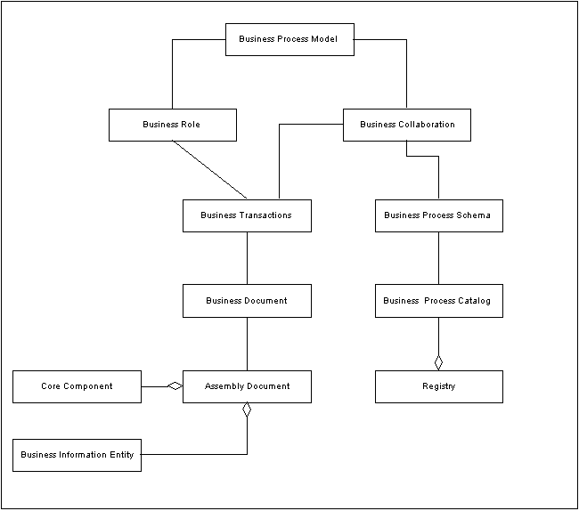

UML has problems with the correct definition of sequence, an important feature of business process management, but does allow choice and multiple triggering inputs to be clearly identified.

From a linguistic point of view a UML model can be thought of as a set of entities (things that have names which are nouns) that are linked by relationships (lines whose names are verbs). Entities have properties (whose values provide adjectives that qualify the nouns) and relationships have qualifications (whose values provide adverbs that qualify the verbs).

A UMM Business Operations Map (BOM), which forms the basis for ebXML business models, has the following typical representation:
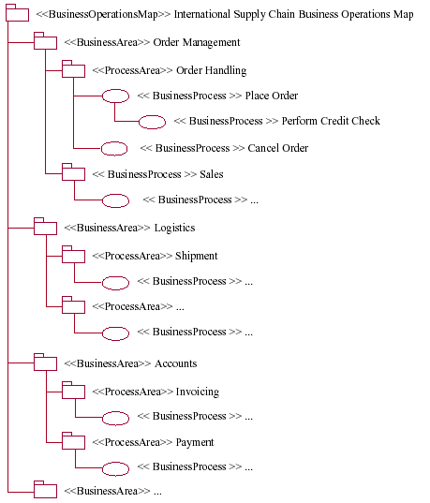

where the following example definitions are used to define the Order Handling Process Area and Place Order Business Process:
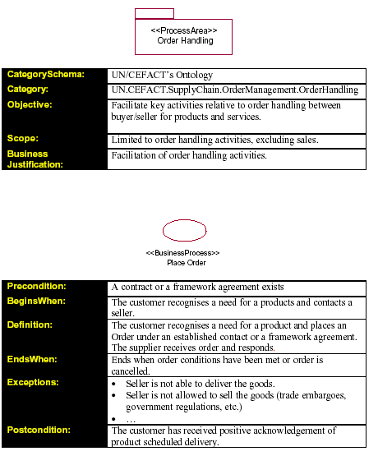

The Centre for User-oriented IT Design (CID) at the Swedish Royal Institute of Technology (KTH) have developed a technique for generalizing UML models to provide Unified Language Modeling (ULM) that allows formal models to be expressed in terms that are easily understood by businesses. The following diagrams summarize this technique:

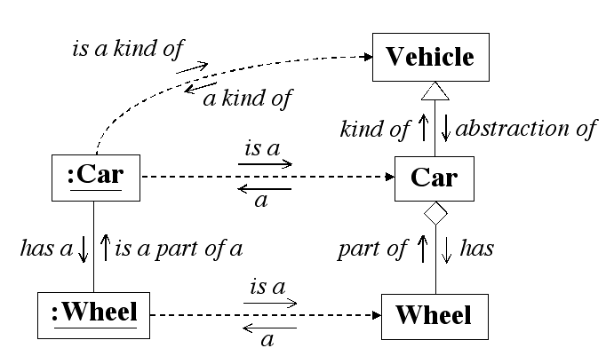
The basic principles for Unified Language Modeling

Using this technique you can understand that:
- The concept called car represents kind of vehicle
- The concept called vehicle is an abstraction of the concept called car
- The concept called wheel forms a part of a car
- A car has one or more wheels
- A specific car (:car) is an instance of the car concept
- A specific wheel (:wheel) is an instance of the wheel concept
- A specific wheel is a part of a specific car
- A specific car is a kind of vehicle

The Common Warehouse Metamodel (CWM) Business Nomenclature Package

The following diagram summarizes the parts of the Open Management Group’s Common Warehouse Metamodel (OMG CWM) Business Nomenclature Package:

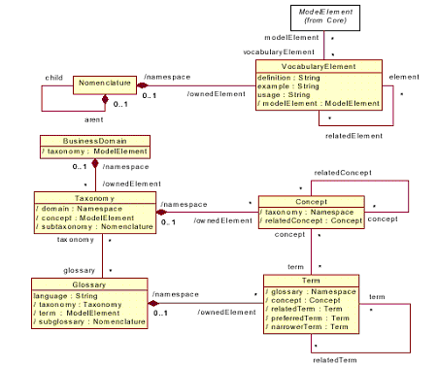
The OMG model considers Taxonomies to consist of a number of Concepts, which may or may not have Related Concepts. A Taxonomy may be related to a Glossary, which contains one or more Term, which may have a Preferred Term, a number of Related Terms and one or more Narrower Terms. Terms can be related to Concepts in a Taxonomy.

ISO 11179: Specification and Standardization of Data Elements

As noted in ISO DTR 20943, Procedures for achieving metadata registry (MDR) content consistency, the two types of abstraction of most interest to data element development are specialization/generalization and decomposition/aggregation.
Specialization/generalization is a relationship between two classes, where all items in one (subclass) are also in the other (superclass). Decomposition/aggregation relates an item to its parts. Decomposition may be described as "x is a part of y,"
or the part-of relationship. The reverse, aggregation, shows that y may be composed of x among other items.

The ISO/IEC 11179-3 metamodel does not provide for linking of data elements. A registration authority recording such data elements, however, might choose to extend the model to link data elements based on their layers of abstraction, including generalization to specialization, and other relationships. Linkages can occur in both vertical relationships (e.g., from general to more specific) and horizontal relationships (e.g., with equivalent layers of specialization). They can also be linked according to other relationships (e.g., data elements that are always used together). Vertical relationships are those where a specialized data element that has been registered for a particular purpose is related to a generalized data element that is intended for a general purpose. Horizontal relationships are those where data elements with different names have equivalent definitions that represent the same layer of specialization, with equivalent data value domains.

When using a top-down approach to ISO 11179 data element registration, small amounts of data are often added to a registry in groups or rather than as individual data elements. When a classified group of data elements is to be added to the registry, the analyst might choose to identify the conceptual domains that are relevant to the group, consider their value meanings, and work down to data elements.

Figure 2 shows the Order of Registering Components for Top Down Registration of a Data Element defined in ISO DTR 20943.

1 Conceptual Domain (CD)
CD Context
CD Name
CD Definition
CD Identifier
CD Registration Status
CD Administrative Status
2 Value Meaning (VM)
VM Description
VM Begin Date
VM End Date
VM Identifier
3 Data Element Concept (DEC)
DEC Context
DEC Name
DEC Definition
Object Class
Object Class Qualifier
Property
Property Qualifier
DEC Identifier
DEC Registration Status
DEC Administrative Status
4 Value Domain (VD)
VD Context
VD Name
VD Definition/Description
VD Identifier
Datatype
Minimum Characters
Maximum Characters
Unit of Measure
Precision
VD Origin
VD Explanatory Comment
Permissible Values (PV)
PV Begin Date
PV End Date
Representation Class
Representation Class Qualifier
VD Registration Status
VD Administrative Status
5 Data Element (DE) Definition and Name
DE Context
DE Definition
DE Name
Registration Authority Identifier
DE Identifier:Version Identifier
DE Example
DE Origin
DE Comment
DE Registration Status
DE Administrative Status

Figure 3: Order of Registering Components for Top Down Registration of a Data Element

The International Standard for Industrial Classification (ISIC)

ISIC Version 3.0 (ISIC3) is the primary scheme used by governments throughout the world to classify business activity. It forms the basis of the Euopean NACE classification of EU economic activity. ISIC uses the following top-level hierarchy:
- A - Agriculture, hunting and forestry
- B - Fishing
- C - Mining and quarrying
- D - Manufacturing
- E - Electricity, gas and water supply
- F - Construction
- G - Wholesale and retail trade; repair of motor vehicles, motorcycles and personal
and household goods
- H - Hotels and restaurants
- I - Transport, storage and communications
- J - Financial intermediation
- K - Real estate, renting and business activities
- L - Public administration and defence; compulsory social security
- M - Education
- N - Health and social work
- O - Other community, social and personal service activities
- P - Private households with employed persons
- Q - Extra-territorial organizations and bodies
Each of these subdivisions is further subdivided. For example, the Manufacturing subdivision is further subdivided into:

- 15 - Manufacture of food products and beverages
- 16 - Manufacture of tobacco products
- 17 - Manufacture of textiles
- 18 - Manufacture of wearing apparel; dressing and dyeing of fur
- 19 - Tanning and dressing of leather; manufacture of luggage, handbags, saddlery,
harness and footwear
- 20 - Manufacture of wood and of products of wood and cork, except furniture;
manufacture of articles of straw and plaiting materials
- 21 - Manufacture of paper and paper products
- 22 - Publishing, printing and reproduction of recorded media
- 23 - Manufacture of coke, refined petroleum products and nuclear fuel
- 24 - Manufacture of chemicals and chemical products
- 25 - Manufacture of rubber and plastics products
- 26 - Manufacture of other non-metallic mineral products
- 27 - Manufacture of basic metals
- 28 - Manufacture of fabricated metal products, except machinery and equipment
- 29 - Manufacture of machinery and equipment
- 30 - Manufacture of office, accounting and computing machinery
- 31 - Manufacture of electrical machinery and apparatus
- 32 - Manufacture of radio, television and communication equipment and apparatus
- 33 - Manufacture of medical, precision and optical instruments, watches and clocks
- 34 - Manufacture of motor vehicles, trailers and semi-trailers
- 35 - Manufacture of other transport equipment
- 36 - Manufacture of furniture
- 37 - Recycling
These upper levels of the ISIC scheme show the typical problems that occur when you try to group together subjects into a single hierarchy. For example, the topmost level A shows that activities related to land use other than those associated with property have been grouped together, but the name applied to them does not reflect the reason for this grouping, but instead is simply the sum of the lower-level activities that make up the group.

Similar problems occur in the relationships between different levels. For example, the Manufacture of food products and beverages is part of the Manufacturing set of activities (D15) and not in any way associated with the production of the raw materials used therein, which generally comes under the heading Agriculture. Similarly the Manufacture of basic metals is not associated with the Mining and quarrying needed to obtain the raw materials for the processes.

These problems could be overcome by adopting a polyhierarchical system, which allowed the fact that the inputs from one chain came from the lower levels of a second chain, but to date most industrial classification schemes rely on single levels of nested classes.

It is unlikely that people will use the terms used in the ISIC headings as the basis for asking questions about classification schemes. It is, therefore, necessary to consider what terms users are likely to use to identify each of these terms. A more natural set of simple-to-understand top-level headings might include:

- Food
- Energy
- Raw materials
- Manufactured Goods
- Retailing
- Financial Services
- Transport
- Recreation
- Personal Services
- Property
- Civil Engineering
- Education
- Health and Social Services
- Public Administration
- Non-profit organizations

It should be noted that the ISIC listing is only available in three languages, English, French and Spanish. Translations into other languages would be needed to provide a truly multilingual classification scheme.

Proposed Approach
The ontology representation language should be expressed in XML so that individual components of it can be referenced as component parts of either a Unique Resource Indicator (URI), XML Path definition or XML Query.

The underlying structure of the XML should be based on the concepts described in the EAGLES framework, but with alternative forms of element names based on typical business renditions of technical terms (e.g. BroaderTerm in place of Hypernym). The terms to be adopted form EAGLES, and their equivalent business terms are shown in the following table:

Linguistic Terminology | Ontological Terminology | Business Terminology
Phrase | Concept | Term/Name
Hypernym | Superclass | Broader Term
Holonym | Subclass | Narrower Term
Synonym | Synonym | Alternative Term
Near-Synonym |  | Partially Matches  Includes
 |  | No Equivalent*
Holonym |  | Forms Part Of
Meronym |  | Has Part  Has Process
Antonym |  | Opposite
 | Restriction | Constraint  Excludes
 | Association | UsedBy  RelatedTo  ReverseOf
Measurement |  | MeasurementsRequired  MeasurementType  PermittedUnit
Time |  | TimesRequired  TimeType
* Indicates that a particular language has no matching term

Entries should be provided with metadata which is defined by reference to existing sources of information or by use of standardized metadata descriptors. Each term must be assigned to at least one subject domain, ideally by linking it to a standardized domain identified within ISIC.

These terms can be used to create the following XML DTD:

<?xml version="1.0" encoding="UTF-8"?>
<!--DTD for defining the Multilingual Upper-Level Electronic Commerce Ontology (MULECO)
© Martin Bryan of The SGML Centre (www.sgml.u-net.com) 25th January 2002 -->
<!--Entity used to indicate that attribute value should be expressed as a valid URL (or as a pointer to an ID assigned in the ontology).-->
<!ENTITY % URL "CDATA">
<!ELEMENT Ontology (Term|TimeType|MeasurementType|PermittedUnit)+>
<!ATTLIST Ontology
Region %URL; #IMPLIED
Industry %URL; #IMPLIED
Process %URL; #IMPLIED
>
<!ELEMENT Term (SubjectDomain+, Definition+, Name+, NoEquivalent*,
(AlternativeTerm | Synonym)*, (PartiallyMatches | Includes |
NearSynonym)*, (BroaderTerm | Hypernym)*, (NarrowerTerm | Hyponym)*,
(FormsPartOf | Holonym)*, (HasPart | HasProcess | Meronym)*,
(Opposite | Antonym)*, (Restriction | Constraint | Excludes)*,
(UsedBy | RelatedTo | ReverseOf)*, (MeasurementsRequired |
TimesRequired)*)>
<!ATTLIST Term
ID ID #REQUIRED
RecordedBy CDATA #REQUIRED
Organization CDATA #IMPLIED
WhenRecorded CDATA #REQUIRED
>
<!--Pointer to subject domains that this term is used within.
(Subject domains may be defined in a separate onotology.)-->
<!ELEMENT SubjectDomain (Label*)>
<!ATTLIST SubjectDomain
xlink:href %URL; #REQUIRED
LabelsID ID #IMPLIED
LabelsRef IDREF #IMPLIED
>
<!--Formal definition of term. Must be at least one. If more than one
the values of their xml:lang attributes must differ.-->
<!ELEMENT Definition (#PCDATA | html:p)*>
<!ATTLIST Definition
xml:lang CDATA #IMPLIED
RecordedBy CDATA #IMPLIED
Organization CDATA #IMPLIED
WhenRecorded CDATA #IMPLIED
>
<!--Name by which term is known within specified SubjectDomains-->
<!ELEMENT Name (#PCDATA)>
<!ATTLIST Name
xml:lang CDATA #IMPLIED
RecordedBy CDATA #IMPLIED
Organization CDATA #IMPLIED
WhenRecorded CDATA #IMPLIED
>
<!--Identifies languages for which there is no equivalent term-->
<!ELEMENT NoEquivalent EMPTY>
<!ATTLIST NoEquivalent
xml:lang CDATA #REQUIRED
RecordedBy CDATA #IMPLIED
Organization CDATA #IMPLIED
WhenRecorded CDATA #IMPLIED
>
<!--Alternative name by which term is known in an identified domain
(must share definition used for name exactly, otherwise it is a
NearSynonym). (Technically these are referred to as Synonyms, but
for convenience of use the AlternativeTerm element is defined as an
equivalent.)-->
<!ELEMENT AlternativeTerm (#PCDATA)>
<!ATTLIST AlternativeTerm
xml:lang CDATA #REQUIRED
RecordedBy CDATA #REQUIRED
Organization CDATA #IMPLIED
WhenRecorded CDATA #REQUIRED
SubjectDomain %URL; #IMPLIED
>
<!ELEMENT Synonym (#PCDATA)>
<!ATTLIST Synonym
xml:lang CDATA #REQUIRED
RecordedBy CDATA #REQUIRED
Organization CDATA #IMPLIED
WhenRecorded CDATA #REQUIRED
SubjectDomain %URL; #IMPLIED
>
<!--Name applied in different language (or domain) that is near to
current term but not exactly synonymous (i.e. does not share exactly
the same definition). If the term overlaps with the related term
then it is said to Partially Match it. If it is a subset of the term
(without overlapping into other areas) then the parent term Includes
the near synonym.-->
<!ELEMENT PartiallyMatches (#PCDATA)>
<!ATTLIST PartiallyMatches
xml:lang CDATA #REQUIRED
RecordedBy CDATA #REQUIRED
Organization CDATA #IMPLIED
WhenRecorded CDATA #REQUIRED
SubjectDomain %URL; #IMPLIED
>
<!ELEMENT Includes (#PCDATA)>
<!ATTLIST Includes
xml:lang CDATA #REQUIRED
RecordedBy CDATA #REQUIRED
Organization CDATA #IMPLIED
WhenRecorded CDATA #REQUIRED
SubjectDomain %URL; #IMPLIED
>
<!ELEMENT NearSynonym (#PCDATA)>
<!ATTLIST NearSynonym
xml:lang CDATA #REQUIRED
RecordedBy CDATA #REQUIRED
Organization CDATA #IMPLIED
WhenRecorded CDATA #REQUIRED
SubjectDomain %URL; #IMPLIED
>
<!--Pointer to elements used to define terms whose broader meaning includes this term. (Technically these are referred to as Hypernyms, but for convenience of use the BroaderTerm alternative is a defined equivalent.)-->
<!ELEMENT BroaderTerm (Label*)>
<!ATTLIST BroaderTerm
xlink:href %URL; #REQUIRED
LabelsID ID #IMPLIED
LabelsRef IDREF #IMPLIED
>
<!--Element contents can be empty if the URL pointed to is within the same ontology. Otherwise the name of the term pointed to in an external ontology should be entered as the contents of this element. If labels used here are referenced from elsewhere the LabelsID attribute must be used to name the set. If labels used elsewhere are to be applied to this element the labelsRef attribute must reference the relevant LabelsID.-->-->
<!ELEMENT Hypernym (Label*)>
<!ATTLIST Hypernym
xlink:href %URL; #REQUIRED
LabelsID ID #IMPLIED
LabelsRef IDREF #IMPLIED
>
<!--Element contents can be empty if the URL pointed to is within the same ontology. Otherwise the name of the term pointed to in an external ontology should be entered as the contents of this element. If labels used here are referenced from elsewhere the LabelsID attribute must be used to name the set. If labels used elsewhere are to be applied to this element the labelsRef attribute must reference the relevant LabelsID.-->
<!--Pointer to elements used to define terms whose narrower meaning is included in this term. (Technically these are referred to as Hyponyms, but for convenience of use the NarrowerTerm alternative is a defined equivalent.)-->
<!ELEMENT NarrowerTerm (Label*)>
<!ATTLIST NarrowerTerm
xlink:href %URL; #REQUIRED
LabelsID ID #IMPLIED
LabelsRef IDREF #IMPLIED
>
<!--Element contents can be empty if the URL pointed to is within the same ontology. Otherwise the name of the term pointed to in an external ontology should be entered as the contents of this element. If labels used here are referenced from elsewhere the LabelsID attribute must be used to name the set. If labels used elsewhere are to be applied to this element the labelsRef attribute must reference the relevant LabelsID .-->
<!ELEMENT Hyponym (Label*)>
<!ATTLIST Hyponym
xlink:href %URL; #REQUIRED
LabelsID ID #IMPLIED
LabelsRef IDREF #IMPLIED
>
<!--Element contents can be empty if the URL pointed to is within the same ontology. Otherwise the name of the term pointed to in an external ontology should be entered as the contents of this element. If labels used here are referenced from elsewhere the LabelsID attribute must be used to name the set. If labels used elsewhere are to be applied to this element the labelsRef attribute must reference the relevant LabelsID.-->-->
<!--Pointer to elements used to define terms that provide components used to create the information set defined by term. (Technically these are referred to as Meronyms, but for convenience of use the HasPart alternative is a defined equivalent.)-->
<!ELEMENT HasPart (Label*)>
<!ATTLIST HasPart
xlink:href %URL; #REQUIRED
LabelsID ID #IMPLIED
LabelsRef IDREF #IMPLIED
>
<!--Element contents can be empty if the URL pointed to is within the same ontology. Otherwise the name of the term pointed to in an external ontology should be entered as the contents of this element. If labels used here are referenced from elsewhere the LabelsID attribute must be used to name the set. If labels used elsewhere are to be applied to this element the labelsRef attribute must reference the relevant LabelsID.-->
<!ELEMENT HasProcess (Label*)>
<!ATTLIST HasProcess
xlink:href %URL; #REQUIRED
LabelsID ID #IMPLIED
LabelsRef IDREF #IMPLIED
>
<!--Element contents can be empty if the URL pointed to is within the same ontology. Otherwise the name of the term pointed to in an external ontology should be entered as the contents of this element. If labels used here are referenced from elsewhere the LabelsID attribute must be used to name the set. If labels used elsewhere are to be applied to this element the labelsRef attribute must reference the relevant LabelsID.-->
<!ELEMENT Meronym (Label*)>
<!ATTLIST Meronym
xlink:href %URL; #REQUIRED
LabelsID ID #IMPLIED
LabelsRef IDREF #IMPLIED
>
<!--Element contents can be empty if the URL pointed to is within the same ontology. Otherwise the name of the term pointed to in an external ontology should be entered as the contents of this element. If labels used here are referenced from elsewhere the LabelsID attribute must be used to name the set. If labels used elsewhere are to be applied to this element the labelsRef attribute must reference the relevant LabelsID.-->
<!--Pointer to elements used to define terms for which this term forms a component of the definition. (Technically these are referred to as Holonyms, but for convenience of use the FormsPartOf alternative is a defined equivalent.)-->
<!ELEMENT FormsPartOf (Label*)>
<!ATTLIST FormsPartOf
xlink:href %URL; #REQUIRED
LabelsID ID #IMPLIED
LabelsRef IDREF #IMPLIED
>
<!--Element contents can be empty if the URL pointed to is within the same ontology. Otherwise the name of the term pointed to in an external ontology should be entered as the contents of this element. If labels used here are referenced from elsewhere the LabelsID attribute must be used to name the set. If labels used elsewhere are to be applied to this element the labelsRef attribute must reference the relevant LabelsID.-->
<!ELEMENT Holonym (Label*)>
<!ATTLIST Holonym
xlink:href %URL; #REQUIRED
LabelsID ID #IMPLIED
LabelsRef IDREF #IMPLIED
>
<!--Element contents can be empty if the URL pointed to is within the same ontology. Otherwise the name of the term pointed to in an external ontology should be entered as the contents of this element. If labels used here are referenced from elsewhere the LabelsID attribute must be used to name the set. If labels used elsewhere are to be applied to this element the labelsRef attribute must reference the relevant LabelsID.-->
<!--Pointer to elements used to define the exact opposite of this term. (Technically these are referred to as Antonyms, but for convenience of use the Opposite alternative is a defined equivalent.)-->
<!ELEMENT Opposite (Label*)>
<!ATTLIST Opposite
xlink:href %URL; #REQUIRED
LabelsID ID #IMPLIED
LabelsRef IDREF #IMPLIED
>
<!--Element contents can be empty if the URL pointed to is within the same ontology. Otherwise the name of the term pointed to in an external ontology should be entered as the contents of this element.-->
<!ELEMENT Antonym (Label*)>
<!ATTLIST Antonym
xlink:href %URL; #REQUIRED
LabelsID ID #IMPLIED
LabelsRef IDREF #IMPLIED
>
<!--Element contents can be empty if the URL pointed to is within the same ontology. Otherwise the name of the term pointed to in an external ontology should be entered as the contents of this element. If labels used here are referenced from elsewhere the LabelsID attribute must be used to name the set. If labels used elsewhere are to be applied to this element the labelsRef attribute must reference the relevant LabelsID.-->
<!--Pointer to documents that define constraints on the use of this term. (Technically these are referred to as Restrictions, but for convenience of use the Constraint alternative is a defined equivalent.)-->
<!ELEMENT Constraint (Label*)>
<!ATTLIST Constraint
xlink:href %URL; #REQUIRED
LabelsID ID #IMPLIED
LabelsRef IDREF #IMPLIED
>
<!--Element contents can be empty if the URL pointed to is within the same ontology. Otherwise the name of the term pointed to in an external ontology should be entered as the contents of this element. If labels used here are referenced from elsewhere the LabelsID attribute must be used to name the set. If labels used elsewhere are to be applied to this element the labelsRef attribute must reference the relevant LabelsID.-->
<!ELEMENT Restriction (Label*)>
<!ATTLIST Restriction
xlink:href %URL; #REQUIRED
LabelsID ID #IMPLIED
LabelsRef IDREF #IMPLIED
>
<!--Element contents can be empty if the URL pointed to is within the same ontology. Otherwise the name of the term pointed to in an external ontology should be entered as the contents of this element. If labels used here are referenced from elsewhere the LabelsID attribute must be used to name the set. If labels used elsewhere are to be applied to this element the labelsRef attribute must reference the relevant LabelsID.-->
<!--Pointer to components that may not be included in associated products or processes. (Technically these are also Restrictions, but they are more specific in application that the more generalized constraints definitions, for which no formal language has yet been defined.)-->
<!ELEMENT Excludes (Label*)>
<!ATTLIST Excludes
xlink:href %URL; #REQUIRED
xml:lang CDATA #IMPLIED
LabelsID ID #IMPLIED
LabelsRef IDREF #IMPLIED
>
<!--Element contents can be empty if the URL pointed to is within the same ontology. Otherwise the name of the excluded item as defined in an external ontology should be entered as the contents of this element. Where more than one term applies the language of each term must be identified using the xml:lang attribute. If labels used here are referenced from elsewhere the LabelsID attribute must be used to name the set. If labels used elsewhere are to be applied to this element the labelsRef attribute must reference the relevant LabelsID.-->
<!--Pointer to term that makes use of this term.-->
<!ELEMENT UsedBy (Label*)>
<!ATTLIST UsedBy
xlink:href %URL; #REQUIRED
>
<!--Element contents can be empty if the URL pointed to is within the same ontology. Otherwise the name of the term pointed to in an external ontology should be entered as the contents of this element. If labels used here are referenced from elsewhere the LabelsID attribute must be used to name the set. If labels used elsewhere are to be applied to this element the labelsRef attribute must reference the relevant LabelsID. -->
<!--Pointer to term related to this term, together with name that defines the relationship between this term and the current term.-->
<!ELEMENT RelatedTo (RelationshipName+, RelatedTerm)>
<!ATTLIST RelatedTo
ID ID #REQUIRED
>
<!--Name used to describe relationship between two or more related terms.-->
<!ELEMENT RelationshipName (#PCDATA)>
<!ATTLIST RelationshipName
xml:lang CDATA #IMPLIED
RecordedBy CDATA #REQUIRED
Organization CDATA #IMPLIED
WhenRecorded CDATA #REQUIRED
SubjectDomain %URL; #IMPLIED
>
<!--Where more than one relationship name is defined for a relationship the language of each name must be identified using the xml:lang attribute. -->
<!--Term to which the current term is to be related.-->
<!ELEMENT RelatedTerm (#PCDATA)>
<!ATTLIST RelatedTerm
xlink:href %URL; #REQUIRED
xml:lang CDATA #IMPLIED
>
<!--Element contents can be empty if the URL pointed to is within the same ontology. Otherwise the name of the excluded item as defined in an external ontology should be entered as the contents of this element. -->
<!--Relationship (defined as part of another term) that this relationship is the reverse of.-->
<!ELEMENT ReverseOf (RelationshipName+)>
<!ATTLIST ReverseOf
RelatesTo IDREF #REQUIRED
>
<!--Identification of measurements required to fully define term, process or part-->
<!ELEMENT MeasurementsRequired (MeasurementTypeRef+)>
<!--Pointer to definition of measurement type required.-->
<!ELEMENT MeasurementTypeRef EMPTY>
<!ATTLIST MeasurementTypeRef
MeasurementType IDREF #REQUIRED
>
<!--Definition of measurement type consisting of the names by which the measurement type is referred together with a list of units that are allowed to be used to specify the measurement.-->
<!ELEMENT MeasurementType (MeasurementName+, PermittedUnitRef+)>
<!ATTLIST MeasurementType
ID ID #REQUIRED
>
<!--Name used to request measurement.-->
<!ELEMENT MeasurementName (#PCDATA)>
<!ATTLIST MeasurementName
xml:lang CDATA #IMPLIED
RecordedBy CDATA #REQUIRED
Organization CDATA #IMPLIED
WhenRecorded CDATA #REQUIRED
SubjectDomain %URL; #IMPLIED
>
<!--Where more than one measurement name is defined the language of each name must be identified using the xml:lang attribute. -->
<!--Pointer to definition of the unit type required.-->
<!ELEMENT PermittedUnitRef EMPTY>
<!ATTLIST PermittedUnitRef
Unit IDREF #REQUIRED
>
<!-- Definition of unit that can be used for measurement, consisting of the names by which the unit type is referred together with the string(s) that is used to qualify numbers defined using this unit (e.g. kg or lbs and ozs).-->
<!ELEMENT PermittedUnit (UnitName+,(UnitIdentifier|PermittedValue)+)>
<!ATTLIST PermittedUnit
ID ID #REQUIRED
>
<!--Name used to request measurement.-->
<!ELEMENT UnitName (#PCDATA)>
<!ATTLIST UnitName
xml:lang CDATA #IMPLIED
RecordedBy CDATA #REQUIRED
Organization CDATA #IMPLIED
WhenRecorded CDATA #REQUIRED
SubjectDomain %URL; #IMPLIED
>
<!--Where more than one name is assigned to the unit the language of each name must be identified using the xml:lang attribute. -->
<!--String used to identify the use of number as a measurement or time unit.-->
<!ELEMENT UnitIdentifier (#PCDATA)>
<!ATTLIST UnitIdentifier
Separator CDATA #IMPLIED
Purpose CDATA #IMPLIED
>
<!--Where two or more sub-units share the same separator they must each be assigned a different value for the Purpose attribute. Where it has not been specified, the separator is presumed to be a space or line ending following the contents of the element.-->
<!--String used to indicate specific value of measurement-->
<!ELEMENT PermittedValue (#PCDATA)>
<!ATTLIST PermittedValue
xml:lang CDATA #REQUIRED
RecordedBy CDATA #REQUIRED
Organization CDATA #IMPLIED
WhenRecorded CDATA #REQUIRED
SubjectDomain %URL; #IMPLIED
>
<!--Identification of times required to fully define term, process or part-->
<!ELEMENT TimesRequired (TimeTypeRef+)>
<!--Pointer to definition of time type required.-->
<!ELEMENT TimeTypeRef EMPTY>
<!ATTLIST TimeTypeRef
TimeType IDREF #REQUIRED
>
<!--Definition of time type consisting of the names by which the time type is referred together with a list of units that are allowed to be used to specify the time.-->
<!ELEMENT TimeType (TimeName+, PermittedUnitRef+)>
<!ATTLIST TimeType
ID ID #REQUIRED
>
<!--Name used to request time.-->
<!ELEMENT TimeName (#PCDATA)>
<!ATTLIST TimeName
xml:lang CDATA #IMPLIED
RecordedBy CDATA #REQUIRED
Organization CDATA #IMPLIED
WhenRecorded CDATA #REQUIRED
SubjectDomain %URL; #IMPLIED
>
<!--Where more than one time name is defined the language of each name must be identified using the xml:lang attribute. -->
<!--Element used to label a link to a service that is not defined multilingually.-->
<!ELEMENT Label (#PCDATA)>
<!ATTLIST Label
xml:lang CDATA #REQUIRED
RecordedBy CDATA #IMPLIED
Organization CDATA #IMPLIED
WhenRecorded CDATA #IMPLIED
SubjectDomain %URL; #IMPLIED
>
<!--Element inherited from HTML specification.-->
<!ELEMENT html:p (#PCDATA)>

A simplified example of the use of this DTD might have the following form:

<Ontology
Region="http://www.iso.org/ISO639/EU"
Industry=”http://esa.un.org/unsd/registry/ISIC3/”>
...
<Term ID="ISIC3-D15"
RecordedBy="Martin Bryan" WhenRecorded="2002-01-02">
<SubjectDomain xlink:href="#ISIC3-D"/>
<Definition xml:lang="EN">
Manufacture of food products and bevarages</Definition>
<Definition xml:lang="FR">
Fabrication de produits alimentair&eacute;s et de boissons
</Definition>
<Definition xml:lang="ES">
Elaboraci&oacute;n de productos alimenticios y bebidas
</Definition>
<Name xml:lang="EN">Food Products</Name>
<Name xml:lang="FR">Alimentaires</Name>
<Name xml:lang="ES">Alimenticios</Name>
<AlternativeTerm xml:lang="EN"
RecordedBy="Martin Bryan" WhenRecorded="2002-01-02">
Processed Food</AlternativeTerm>
<Includes xml:lang="EN"
RecordedBy="Martin Bryan" WhenRecorded="2002-01-02">
Drinks</Includes>
<Includes xml:lang="FR"
RecordedBy="Martin Bryan" WhenRecorded="2002-01-02">
Boisson</Includes>
<BroaderTerm xlink:href="#ISIC3-D"/>
<NarrowerTerm xlink:href="#ISIC3-D151"/>
<NarrowerTerm xlink:href="#ISIC3-D152"/>
<NarrowerTerm xlink:href="#ISIC3-D153"/>
<NarrowerTerm xlink:href="#ISIC3-D154"/>
<FormsPartOf xlink:href="SupplyChain.xml#Food">
<Label xml:lang="EN">Foodstuffs Supply Chain</Label>
<Label xml:lang="ES">Comestibles suministro</Label>
<Label xml:lang="FR">Alimentaire</Label>
</FormsPartOf>
<HasProcess xlink:href="BusinessProcesses.xml#ProductInformation">
<Label xml:lang="EN">Product Information</Label>
<Label xml:lang="ES">Productos</Label>
<Label xml:lang="FR">Produits</Label>
</HasProcess>
<HasProcess xlink:href="BusinessProcesses.xml#Order">
<Label xml:lang="EN">Order</Label>
<Label xml:lang="ES">Orden</Label>
<Label xml:lang="FR">Ordre</Label>
</HasProcess>
<HasProcess xlink:href="BusinessProcesses.xml#Delivery">
<Label xml:lang="EN">Delivery Details</Label>
<Label xml:lang="ES">Reparto</Label>
<Label xml:lang="FR">Livraison</Label>
</HasProcess>
<HasProcess xlink:href="BusinessProcesses.xml#Invoice">
<Label xml:lang="EN">Invoice</Label>
<Label xml:lang="ES">Factura</Label>
<Label xml:lang="FR">Facturer</Label>
</HasProcess>
<HasProcess xlink:href="BusinessProcesses.xml#Payment">
<Label xml:lang="EN">Payment</Label>
<Label xml:lang="ES">Pago</Label>
<Label xml:lang="FR">Paiement</Label>
</HasProcess>
</Term>
...
<MeasurementType ID=”weight”>
<MeasurementName xml:lang=”EN” RecordedBy=”Martin Bryan”
WhenRecorded=”2002-01-06”>Weight</MeasurementName>
<MeasurementName xml:lang=”FR” RecordedBy=”Martin Bryan”
WhenRecorded=”2002-01-06”>Poid</MeasurementName>
<MeasurementName xml:lang=”ES” RecordedBy=”Martin Bryan”
WhenRecorded=”2002-01-06”>Peso</MeasurementName>
<PermittedUnitRef Unit=”kg”/>
<PermittedUnitRef Unit=”lb”/>
<PermittedUnitRef Unit=”lbs-and-ozs”/>
<PermittedUnitRef Unit=”tonnes”/>
<PermittedUnitRef Unit=”hundredweight”/>
</MeasurementType>
...
<PermittedUnit ID=”kg”>
<UnitName xml:lang=”EN ES FR” RecordedBy=”Martin Bryan”
WhenRecorded=”2002-01-06”>kilo</UnitName>

<UnitName xml:lang=”EN FR” RecordedBy=”Martin Bryan”
WhenRecorded=”2002-01-06”>kilogramme</UnitName>
<UnitName xml:lang=”EN” RecordedBy=”Martin Bryan”
WhenRecorded=”2002-01-06”>kilogram</UnitName>
<UnitIdentifier>kg</UnitIdentifier>
</PermittedUnit>
<PermittedUnit ID=”lbs-and-ozs”>
<UnitName xml:lang=”EN” RecordedBy=”Martin Bryan”
WhenRecorded=”2002-01-06”>Pounds and ounces</UnitName>
<UnitIdentifier>lb</UnitIdentifier>
<UnitIdentifier>oz</UnitIdentifier>
</PermittedUnit>
...
<TimeType ID=”DeliveryDate”>
<MeasurementName xml:lang=”EN” RecordedBy=”Martin Bryan”
WhenRecorded=”2002-01-06”>Delivery Date</MeasurementName>
<MeasurementName xml:lang=”FR” RecordedBy=”Martin Bryan”
WhenRecorded=”2002-01-06”>Temp de deliverance</MeasurementName>
<MeasurementName xml:lang=”ES” RecordedBy=”Martin Bryan”
WhenRecorded=”2002-01-06”>Fecha da reparto</MeasurementName>
<PermittedUnitRef Unit=”day”/>
<PermittedUnitRef Unit=”date-and-time”/> >
</MeasurementType>
<PermittedUnit ID=”date-and-time”>
<UnitName xml:lang=”EN” RecordedBy=”Martin Bryan”
WhenRecorded=”2002-01-06”>Date and Time</UnitName>
<UnitIdentifier Separator=”-” Purpose=”year”/>
<UnitIdentifier Separator=”-” Purpose=”month”/>
<UnitIdentifier Separator=”T” Purpose=”date”/>
<UnitIdentifier Separator=”:” Purpose=”hour”/>
<UnitIdentifier Separator=”:” Purpose=”minute”/>
</PermittedUnit>
<PermittedUnit ID=”day”>
<UnitName xml:lang=”EN” RecordedBy=”Martin Bryan”
WhenRecorded=”2002-01-06”>Day and Time</UnitName>
<PermittedValue xml:lang=”EN” RecordedBy=”Martin Bryan”
WhenRecorded=”2002-01-06”>Monday</PermittedValue>
<PermittedValue xml:lang=”EN” RecordedBy=”Martin Bryan”
WhenRecorded=”2002-01-06”>Tuesday</PermittedValue>
<PermittedValue xml:lang=”EN” RecordedBy=”Martin Bryan”
WhenRecorded=”2002-01-06”>Wednesday</PermittedValue>
<PermittedValue xml:lang=”EN” RecordedBy=”Martin Bryan”
WhenRecorded=”2002-01-06”>Thursday</PermittedValue>
<PermittedValue xml:lang=”EN” RecordedBy=”Martin Bryan”
WhenRecorded=”2002-01-06”>Friday</PermittedValue>
<PermittedValue xml:lang=”EN” RecordedBy=”Martin Bryan”
WhenRecorded=”2002-01-06”>Saturday</PermittedValue>
<PermittedValue xml:lang=”ES” RecordedBy=”Martin Bryan”
WhenRecorded=”2002-01-06”>lunes</PermittedValue>
<PermittedValue xml:lang=”ES” RecordedBy=”Martin Bryan”
WhenRecorded=”2002-01-06”>martes</PermittedValue>
<PermittedValue xml:lang=”ES” RecordedBy=”Martin Bryan”
WhenRecorded=”2002-01-06”>miércoles</PermittedValue>
<PermittedValue xml:lang=”ES” RecordedBy=”Martin Bryan”
WhenRecorded=”2002-01-06”>jueves</PermittedValue>
<PermittedValue xml:lang=”ES” RecordedBy=”Martin Bryan”
WhenRecorded=”2002-01-06”>viernes</PermittedValue>
<PermittedValue xml:lang=”ES” RecordedBy=”Martin Bryan”
WhenRecorded=”2002-01-06”>sábado</PermittedValue>
<PermittedValue xml:lang=”FR” RecordedBy=”Martin Bryan”
WhenRecorded=”2002-01-06”>lundi</PermittedValue>
<PermittedValue xml:lang=”FR” RecordedBy=”Martin Bryan”
WhenRecorded=”2002-01-06”>mardi</PermittedValue>
<PermittedValue xml:lang=”FR” RecordedBy=”Martin Bryan”
WhenRecorded=”2002-01-06”>mercredi</PermittedValue>
<PermittedValue xml:lang=”FR” RecordedBy=”Martin Bryan”
WhenRecorded=”2002-01-06”>jeudi</PermittedValue>
<PermittedValue xml:lang=”FR” RecordedBy=”Martin Bryan”
WhenRecorded=”2002-01-06”>vendredi</PermittedValue>
<PermittedValue xml:lang=”EN” RecordedBy=”Martin Bryan”
WhenRecorded=”2002-01-06”>samedi</PermittedValue>
</PermittedUnit>
...
</Ontology>

Using the XSL Transformation Language (XSLT), this file can be converted into an HTML file for display on a web browser in the following format:

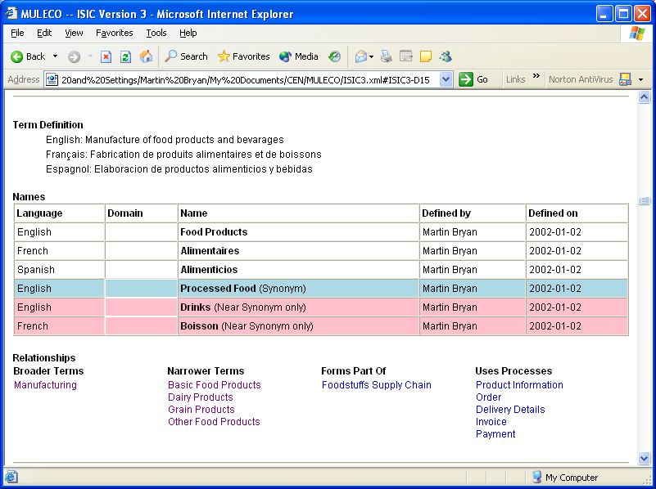
Alternatively the term could be presented graphically as:
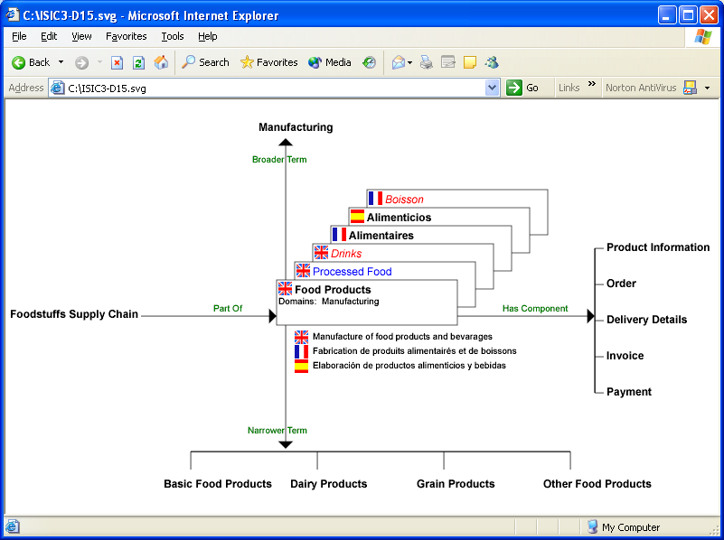
Current Status
MULECO is an on-going project, and as yet no formal set of definitions, or accompanying DTD/Schema, has been agreed. Areas of ongoing study include those currently being undertaken by European research projects such as MILES, CLAMOUR and OntoWeb, and by international e-commerce initiatives such ebXML/ebTWG, related to:

- Formal languages for describing ontologies
- Formal languages for describing multilingual word sets
- Formal models for the maintaining industrial classification schemes
- Formal languages for modelling business processes
- Techniques for the creation and maintenance of process-based ontologies

If you would like to take part in the project please contact our website at http://www.cenorm.be/isss/Workshop/ec/New_Projects.htm#MULECO

Martin Bryan
The SGML Centre
28th January 2002

Annex A: Pictoral representation of MULECO Schema
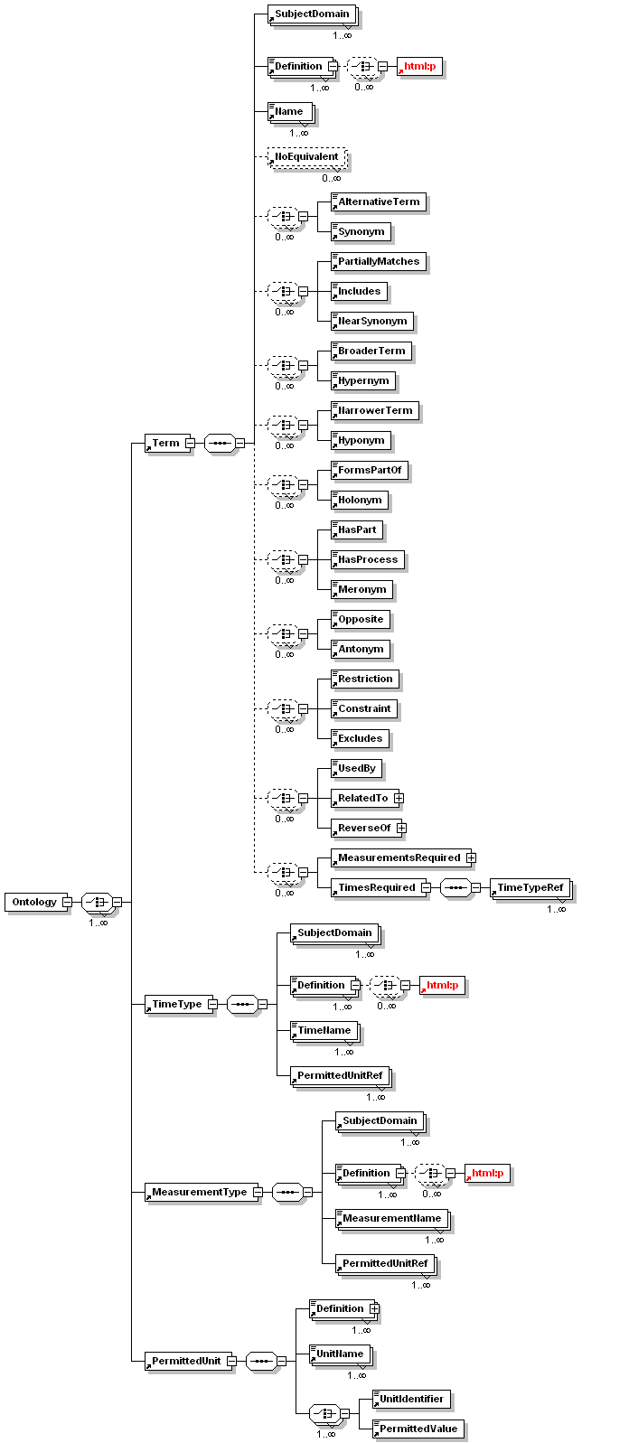

The classes used in programming are typically additive in nature, properties at a lower level being added to those at higher levels. Categories in ontologies, in contrast, are restrictive in nature, the properties at one level distinguishing subsets of the properties applicable at a higher level.

