Comparison of the modeling notations for Business Process and EAI modeling
Draft 0.2
April 25, 2001

Andrzej Bialecki abial@webgiro.com

Purpose and Scope
This document is intended as a general guide to various modeling notations in the area of business process modeling. It is hoped that the material collected herein will help users of commercial products, system integrators and enterprise modelers to:
- better understand the benefits, limitations and correspondence of the notation they use,
- building more interoperable solutions
- produce documentation and product descriptions understandable for wider audience

The material presented below represents a snapshot of notations used at particular time. The author welcomes any contributions, comments or corrections that will help this document to better serve its purpose.

Notation elements for the Business Process modeling.

The following table presents the catalogue of notation symbols commonly used to represent the business processes. The symbols and their corresponding concepts have been organized according to their common base semantics. However, additional details still need to be provided to make clear how their additional semantic differs.

The notation symbols have been collected from the following standards or products:
- UML 1.4: the Jan 2001 RTF version of the OMG standard
- Microsoft BizTalk, Feb 2001 version
- Hewlett-Packard Process Manager v. 3.0
- BEA WebLogic Process Integrator
- Viewlocity Business Modeling Language
The rows in bold represent the fundamental concepts, the other rows (bulleted) present useful shortcuts for the specialized concepts.

The question marks indicate the areas that require further research. The “N/A” marks indicate that this concept is not (directly) available.

Name | Base Semantics | UML 1.4 | MS  BizTalk Server | HP  Process Manager | WebLogic  Process Integrator | BML
Start | Beginning of the process | Start | Begin |  Start Node | Start | 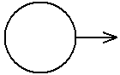 Start
End | End of the process | End | End | Complete Node | Done | 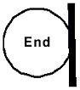 End
- Abort | Unsuccessful end, critical stop, often requires rollbacks | N/A |  Abort |  Abort Node | N/A | N/A
Actors | Represents an acting agent (human or machine), participating in the activities in various roles |  Actor   control (SDProf)   worker (BMProf)  case worker (BMProf) | ? | ? | ? |  Human actor  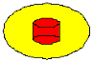 Application
Action | A state with an entry action and at least one outgoing transition involving the implicit event of completing the entry action. | Activity | Activity |  Work Node | Task | 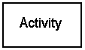 Automated business activity
- Wait for event | An action that waits (either indefinitely or for a specified amount of time) for a specific event to occur. | N/A | Wait | ? | Event (wait) | ?
Action specification | Description of the action. | Textual description (note) | COM   Script (VB ..) | Service spec:  - A ???  - B ??? | - Java method call  - ??? | Textual description (???)
Nested Actions | A group of related actions represented by a super-state symbol. Their execution and transitions are represented by the outgoing transitions from the super-state. The nested actions may have a transactional properties. | 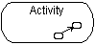  Sub-activity | Transaction boundary  + additional process specification for transaction failure. | ? | ? | 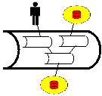  Sub-processes
Event | An instantaneous occurrence that may trigger a transition | 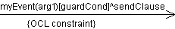  Event | ? | ? | ? | ?
- Send signal | Instantaneous action which results in passing a data object from the current process to the recipient(s). | 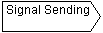  Send signal  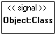 the signal object | 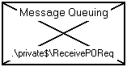  Message queue  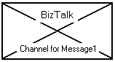  BizTalk messaging | ? | ? | 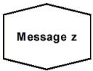  Send message
- Receive signal | Instantaneous action which results in receiving data object from sender to the current process scope. | 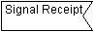  Receive signal  the signal object | Message queue  BizTalk messaging | ? | ? | 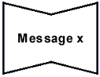  Receive message
Auto-event | An event generated automatically as a result of executing certain action | 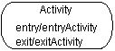  onEntry, onExit | ? | ? | ? | ?
Deferred event | An event whose delivery is postponed – and which may be picked up later by another action | 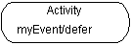  Deferred event | Message queue | ? | ? | ?
- Timed event | Timed events are such that occur in relation to passing of predetermined amount of time. | Keywords: “after”, “when” … | ? | ? | ? | 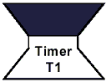 Timer start  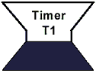 Timer expire
Event specification | Description of an event | Pre-defined (entry, exit).  Syntax:  name(arg:type...)[guard]/action | ? | ? | ? | ?
Alternate execution
- Decision | Selects different possible transitions (alternate paths of execution) | 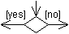  Decision (guarded junction) | 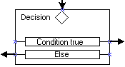  Decision |  Route Node  + rule(s) | Decision (?) | 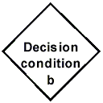 Automated business decision
- Junction | Joins alternative paths of execution into one. | Merge | ? | Merge Node | ? | Connection of transitions (no special symbol)
Parallel execution
- Fork | Indicates that several actions from now on are taking place in parallel paths of execution | 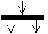  SyncState / Fork |  Fork | Route Node  + rule(s)  + property | Decision (?) | N/A
- Join | Joins the parallel paths of execution – the further execution is postponed until one or all of parallel tasks complete. | 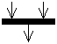  SyncState / Join | AND  OR (XOR?) | Merge Node  + property | AND  OR | N/A
Concurrent execution | Represents the action’s ability to be executed concurrently by multiple threads of control | 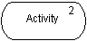  Concurrent invocation | ? | ? | ? | ?
Transition |  | Transition | Transition | Transition | Connector | Transition
- Conditional transition |  | Guard (guarded transition) | Rule language (VBScript ???) | Simple rule language (proprietary) | ? | ?
Transaction | A group of actions having transactional properties (ACID), usually combined with rollback specification. | ? | Transaction boundary | ? | ? | ?
Partition | Partition divides the model into related but logically distinct parts | 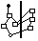  Swim lane | Separate diagrams:  - Control Flow  - Implementation  - Data transform. | ? | ? | 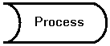  Process boundary
Object | Represents an instance of data related to one or more activities | 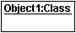 Object   Entity (BMProf) | + property (message specification) | Case Packet  (collection of data objects in process scope) | ? | [msg]  Message instance
- Object responsible for action |  | 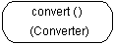  Object responsible for an action | ? | ? | ? | ?
- Object in state |  | 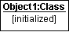  Object in state | ? | ? | ? | ?
- Object flow |  | 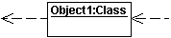 Object flow | 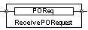  Message flow | ? | ? | ?

Data transformation methodologies

This section is still incomplete.

BizTalk: the mapping tool, and the Data Transformation pages; functoids

