E-Commerce Integration Meta-Framework – Technical Specification (ECIMF-TS)

CEN/ISSS/WS-EC/ECIMF

Draft, version 0.3
November 28, 2001

NOTE: this document is just a placeholder for now. Please contribute the material to be contained here!

Purpose and scope

ECIML Notation

Business Context diagrams
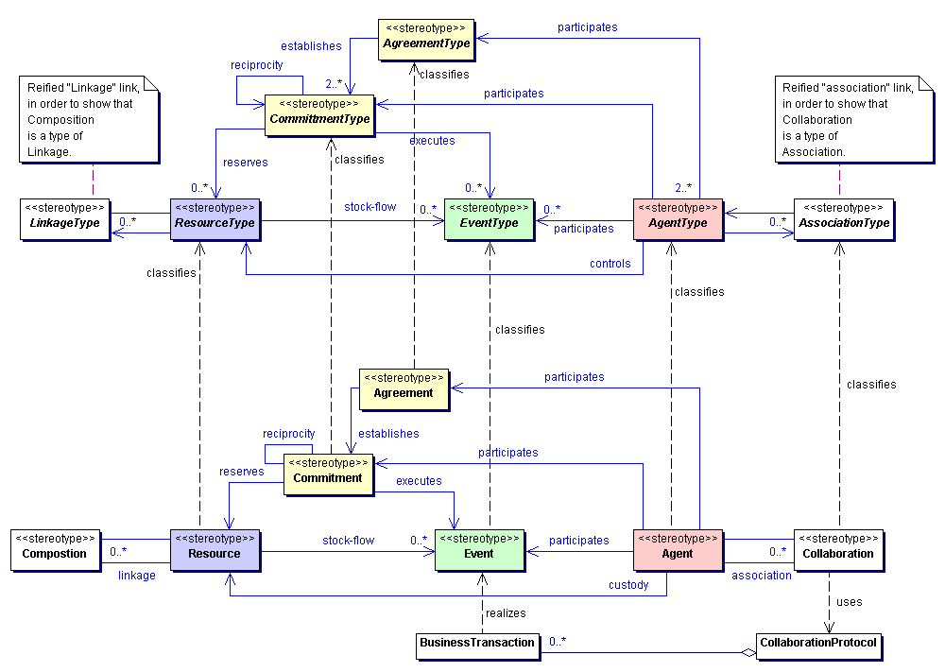

Process mediation diagrams

Semantic translation diagrams
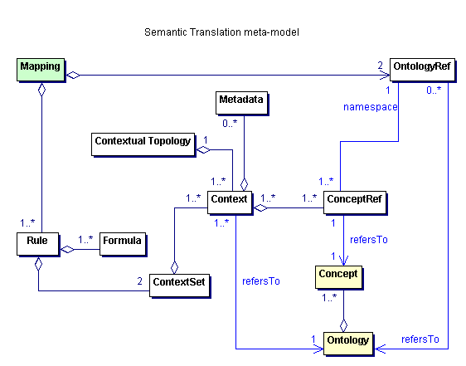

Syntax mapping diagrams

XML Production Rules

Business Context schema

Process mediation schema

Semantic translation schema

Syntax mapping schema

MANIFEST Schema

Example

ECIMF Model

MANIFEST

